**LAB 4**

Install **WDS**by **PowerShell**

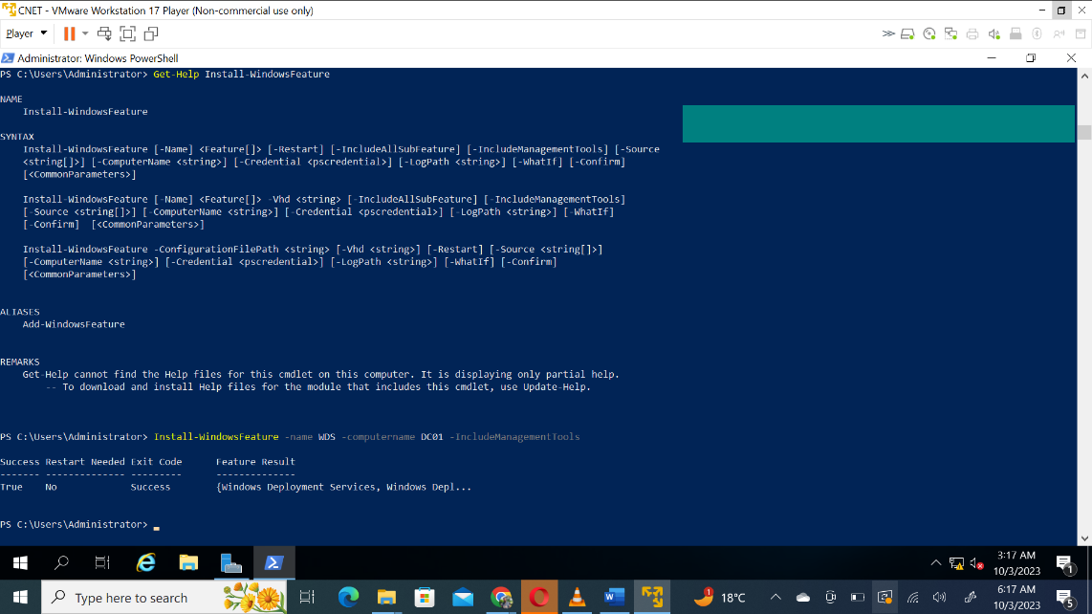

1. Create a new scope called **Win10**

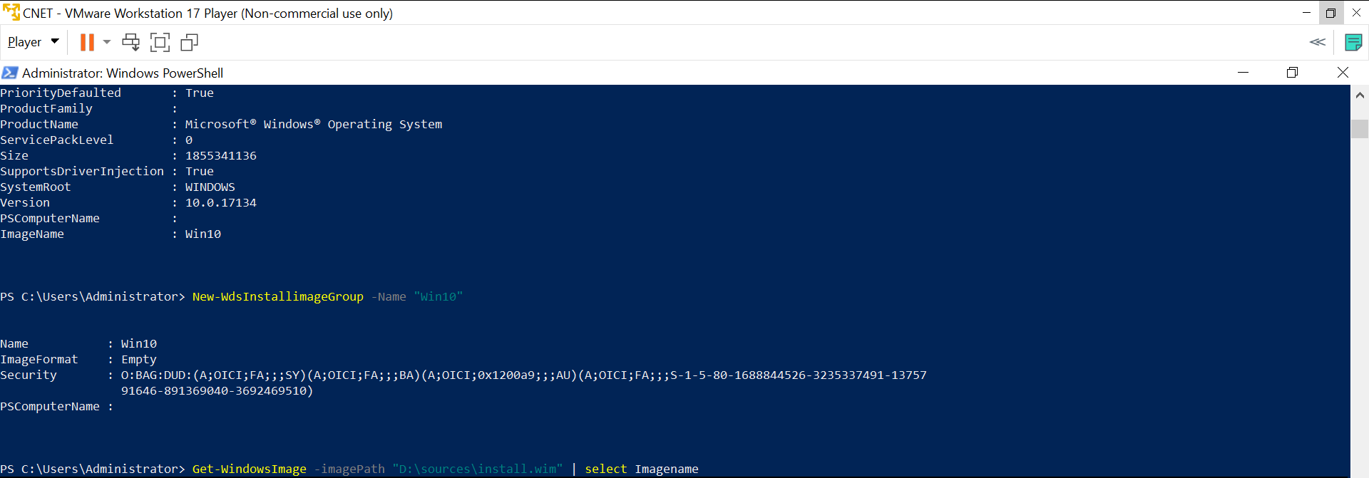

1. Create a new boot called **Win10**

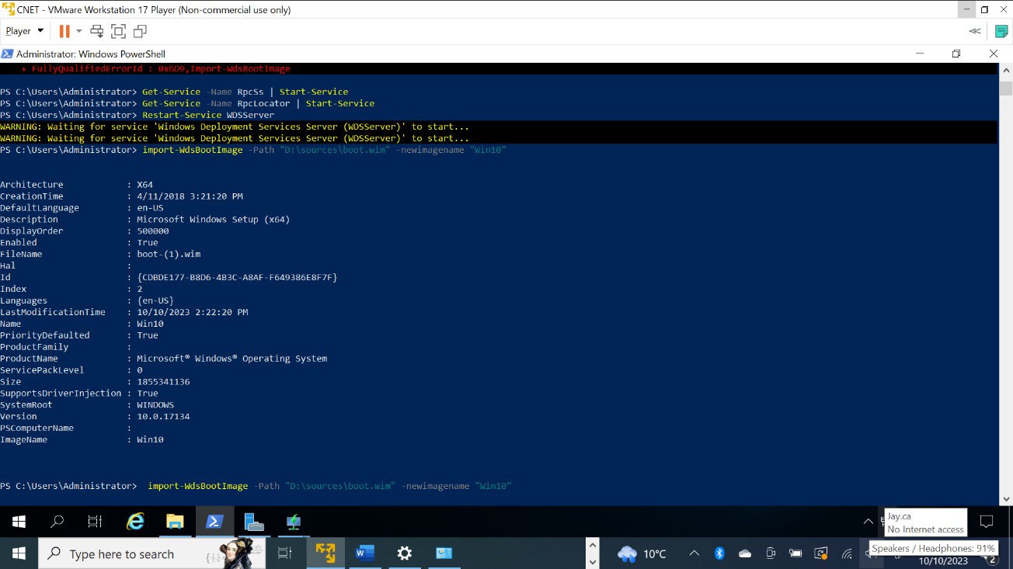

1. **Import-wds**images **install.wim**

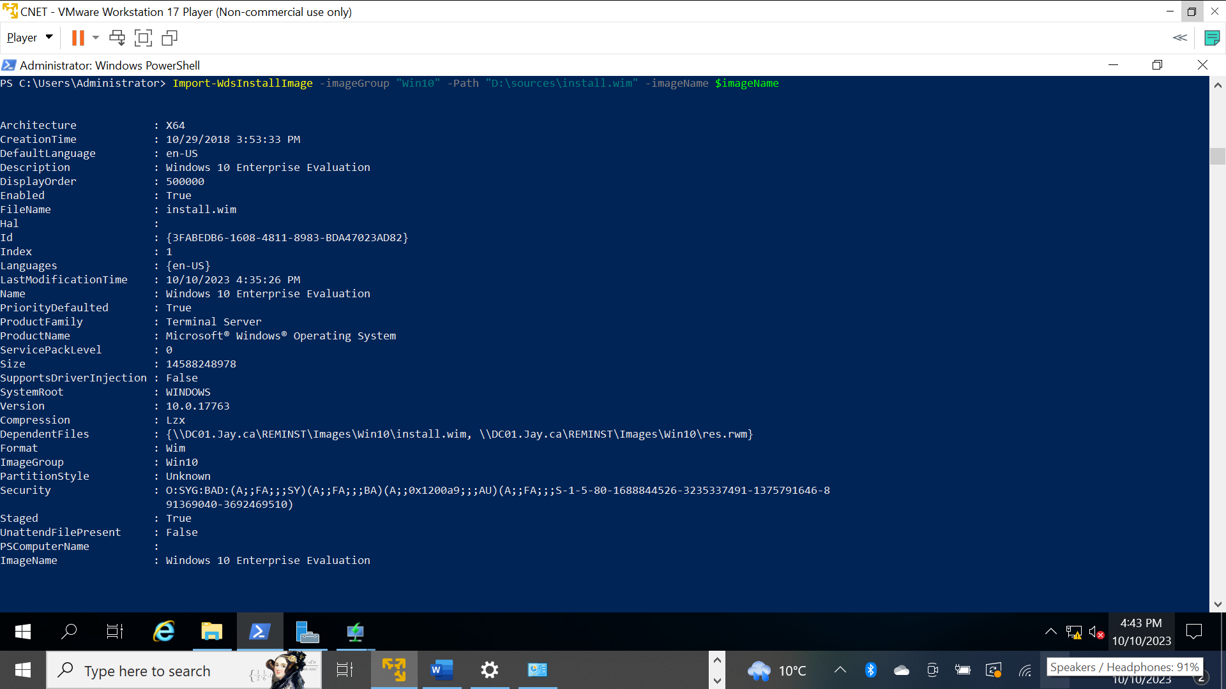

1. **import-wds**boot **boot. Wim**

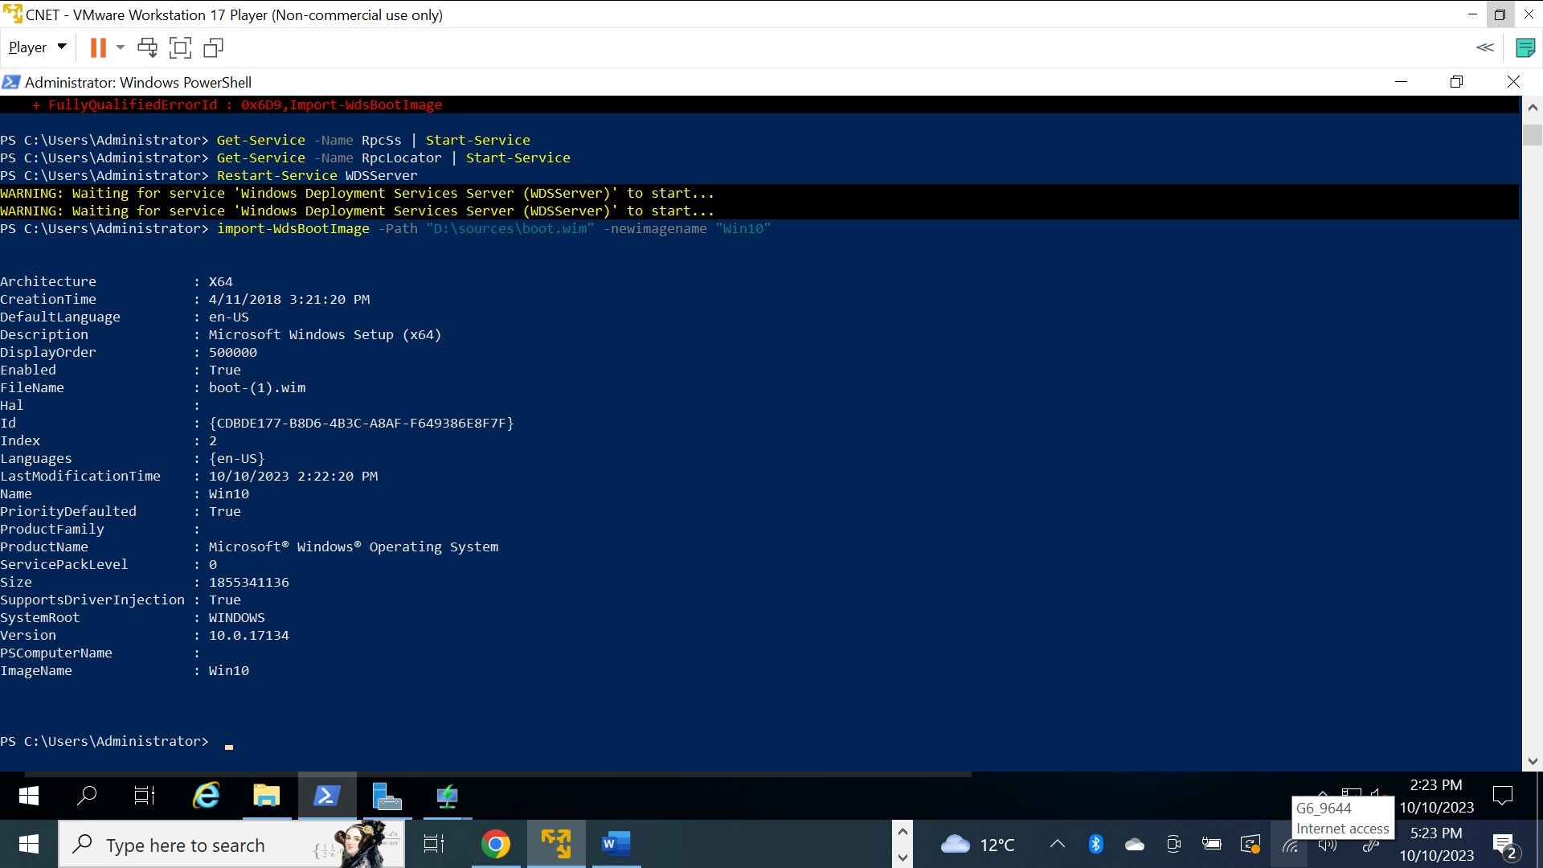

1. Deploy a new **Win10** over the network from WDS

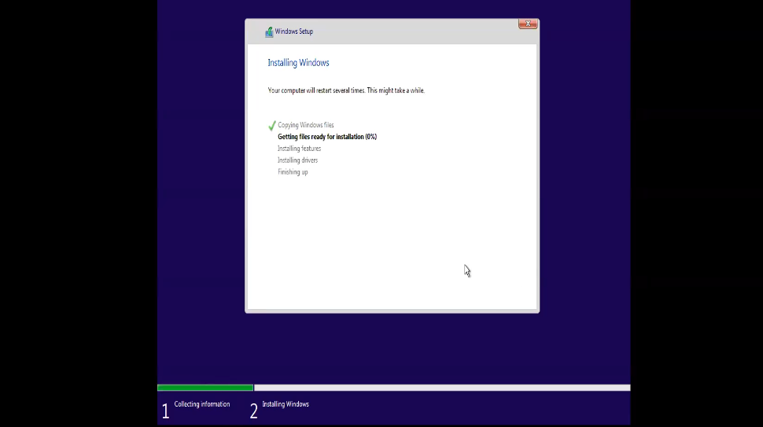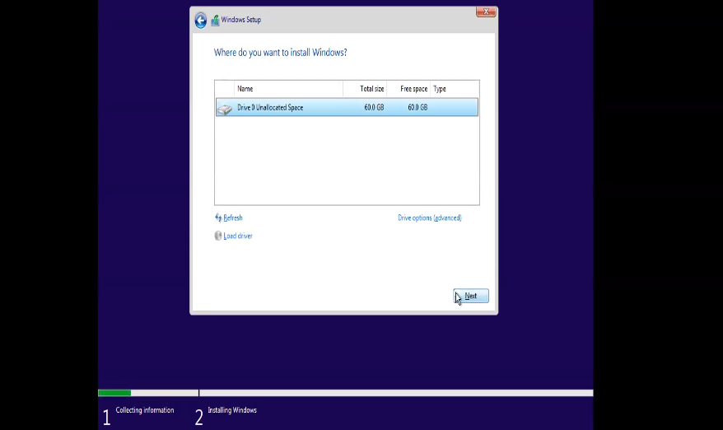

Theoretical parts

1. Describe in 100 words what is the purpose of WDS

Windows Deployment Services (WDS) is a Microsoft server role designed to simplify the deployment of Windows operating systems across multiple computers. It aims to automate and streamline the installation process, allowing IT professionals to deploy Windows images to new or existing machines over a network. WDS facilitates centralized management, reducing the need for manual installation on each computer. It supports a variety of deployment scenarios, including image-based installations, driver provisioning, and unattended installations.

1. Describe in 100 words the purpose of **PXE boot**

The purpose of PXE boot is to streamline the initial deployment or reinstallation of operating systems in computer systems. Instead of relying on local media like a hard drive or USB drive, PXE allows computers to boot from a server's image over the network. This is particularly useful in large-scale IT environments, facilitating automated and centralized deployment of operating systems, configuration management, and software updates without physical media or manual intervention on each machine.

1. Describe in **100**words the purpose of **unattended installation**

Unattended installation is a deployment method used to install an operating system or software without requiring user interaction. Its purpose is to automate the installation process, reducing the need for manual input and ensuring consistency across multiple systems. In operating systems, unattended installation involves providing a configuration file or script with predetermined settings, such as user accounts, network configurations, and application installations. This method is invaluable in large-scale IT environments, where deploying or updating multiple systems simultaneously is common. Unattended installations save time, minimize errors, and enhance efficiency by allowing IT professionals to deploy software across numerous machines with minimal user intervention.